IBDOCIED Security Checkpoint X-Ray Counter IED Verification Test Standard
Description:
Established in this standard are the test method and test object for ensuring that a security checkpoint x-ray is operating and set to optimize detection of the IED threat. This test is specifically designed to verify that the x-ray system is set to a specific level for the sole purpose of verifying its ability to detect an IED type threat. This test can be used for procurement/tender testing but is specifically intended for a daily verification testing of a security screening checkpoints x-ray system.
Only those systems that can pass the IBDOCIED Security Checkpoint X-Ray Counter IED verification standard will be classified as qualified for IBDOCIED Certification.
Testing Procedure:
- The testing will be done by using the Security X-Ray Verification Testing Kit:
(Model number: SVSXR-01.
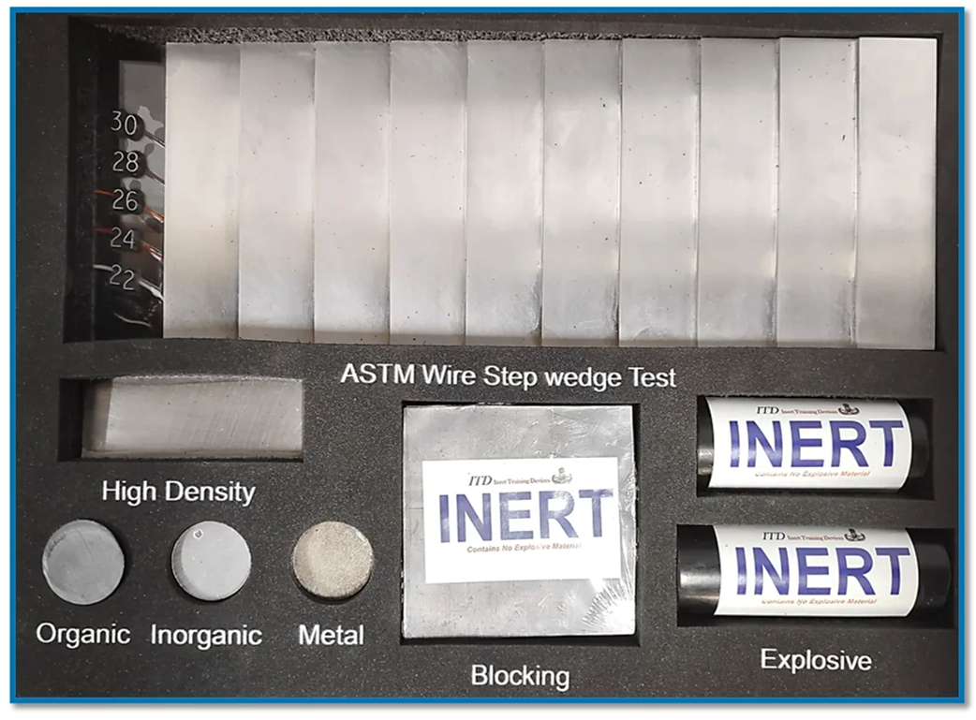
Figure 1: SVSXR-01 security x-ray verification testing kit
- Tests:
- ASTM F792-88 wire step wedge
- High Density Automatic Detection Test
- Materials Discrimination color test
- X-Ray Blocking Test
- Automatic exploisve detection test

- Testing Procedure and Scoring:

- The test kit will be placed on the center of the x-ray belt and scanned. The orientation will be set so the test has the ASTM f792-88 Step wedge at the top of the image. The numbers on the ASTM will be readable when displayed on the screen.
- The ASTM F-792-88 will be scored in two parts with the front section with the wire gauge numbers being the 1st part of the test. For the x-ray system to pass it must be able to fully image all of the wires gauges. If the x-ray system can image each wire you will annotate on the score sheet in each section and award the system a single point. If the systems cannot fully image each wire gauge the system will receive zero points for the test and will fail the entire test. If you are using the test kit to score different systems for a technical evaluation on a procurement or tender each line will receive one point for each wire gauge that can be fully imaged.
- The second part of the ASTM F-792-88 test will be imaging the different gauge wires under the ten steps. For the system to pass the IBDOCIED certification the x-ray must be able to image all of the different gauge wires in all ten steps. This means you must see the complete wire all the way from end to end at each step. If the x-ray system cannot image any part of each step the system fails the test. If you are using the test kit to score different systems for a technical evaluation on a procurement or tender each step and each wire gauge will receive one point for each one that can be fully imaged.
- The third part of the test will be to verify that the x-ray system has the ability to provide a high-density detection capability. The software feature will allow for the maximum absorption % to be adjusted along with the size (cm2) that will alarm. The test object represents the density of a metal pipe bomb and hand grenade. The system must alarm fully on the entire test object. If the system cannot automatically detect the test object the system will fail the test and not be certified by IBDOCIED. If you are using the test kit to score different systems for a technical evaluation on a procurement or tender if the test object is autodetected the system will receive one point.
- The fourth test is the materials discrimination imaging test and shows that the x-ray system can accurately show the correct color ranges.
- Orange color for organic materials Zeff range 0-10
- Green color for inorganic materials Zeff range 11-18
- Blue color for Metals Zeff range 19- 50 plus
- Each section of test four will show up in the image representing the correct color. If the system cannot correctly image any section it will fail the test and receive no point and not be certified by IBDOCIED. If you are using the test kit to score different systems for a technical evaluation on a procurement or tender all three disks must pass and will receive a single point.
- The fifth test is the x-ray blocking test and shows the ability of the x-ray system to image a IED circuit component through a very high-density material. To pass the test the system must be able to image clearly the shape of the 9-volt battery behind the blocking material. If the system cannot image the battery it will not be certified by IBDOCIED. If you are using the test kit to score different systems for a technical evaluation on a procurement or tender you must be able to image the 9 volt to receive a single point.
- The sixth test verifies that the x-ray can provide automatic detection for organic explosives. Both test objects must alarm to pass this test and if the system cannot alarm to each one it will fail and not be certified by IBDOCIED. If you are using the test kit to score different systems for a technical evaluation on a procurement or tender each test object must alarm to receive a single point.
- The scoring sheet below will be used for both IBDOCIED Counter IED certification and for solicitation/tender technical evaluations.
